Guest Guide

Contents
1 Key Aspects 2
1.1 Key box 2
1.2 WIFI 3
1.3 Heating & Hot water 3
1.4 Bins / Waste 4
2 Local Amenities 5
2.1 Food Supplies 5
3 Appliances 6
3.1 Oven 6
3.2 Hob 6

Key Aspects

Key box

The keybox is at the rear of the garage, on the right hand side of this picture | 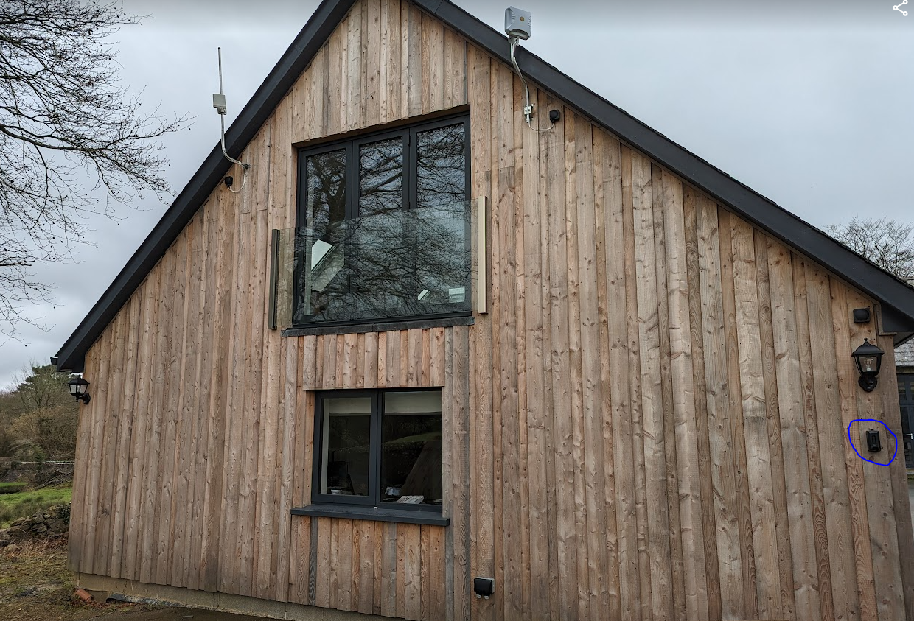

Pull down cover and enter code | Push down open button | Collect keys and garage fob
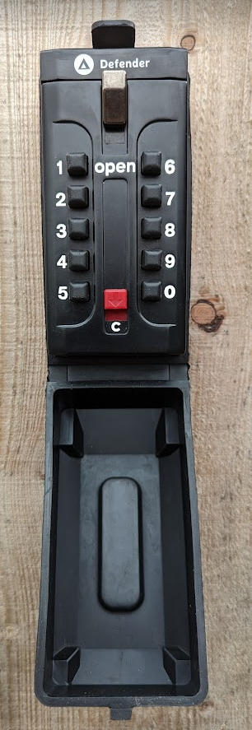 | 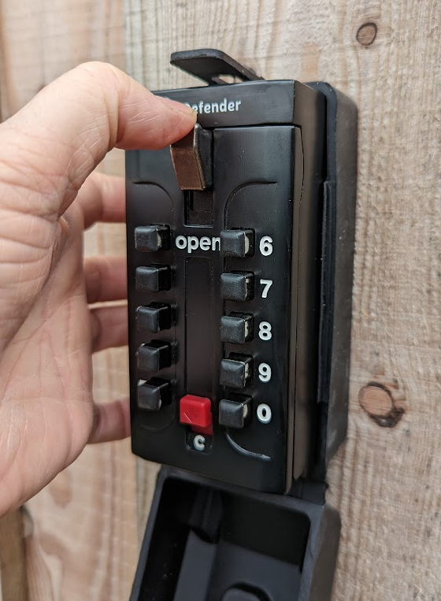 | 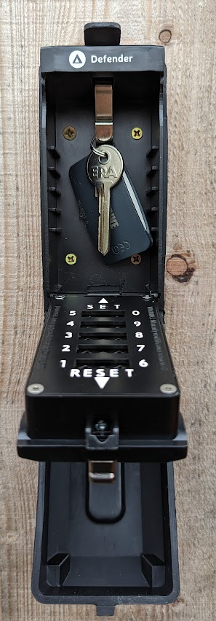

WIFI

Location | Network Name | Password | QR code
Upstairs | YrHenYsgol  or  Cart_House_5Ghz | wolseley | 
Downstairs | Office | wolseley | 

Heating & Hot water

Hot water constantly available on-demand.
The schedule for the heating is set as follows | 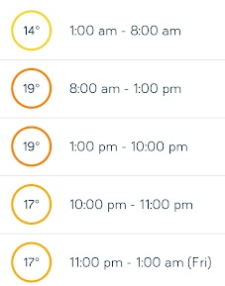
Use the dial on the thermostat to increase the heating if required.  The thermostat is located on the wall in the lounge | 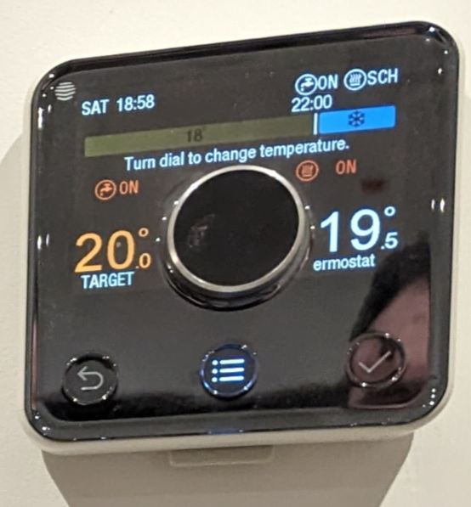

Bins / Waste

Food Waste | There is a small green food waste bind near the sink, spare green/clear bags are under the sink. | Once full, place full bag in the green waste bin at the front door
Recycling | There is a 60L push top bin in the kitchen area, spare clear bags are under the sink. | Place full bags anywhere in the garage
Glass | There is a black plastic bin located in the garage
Waste | There is a 30L push top bin in the kitchen area, spare black bags are under the sink | Place full bags anywhere in the garage

Here are further guides on recycling in Ceredigion
https://www.ceredigion.gov.uk/media/5858/household-waste-collection-service.pdf
https://www.ceredigion.gov.uk/resident/bins-recycling/a-z-of-waste/

Local Amenities

Food Shopping

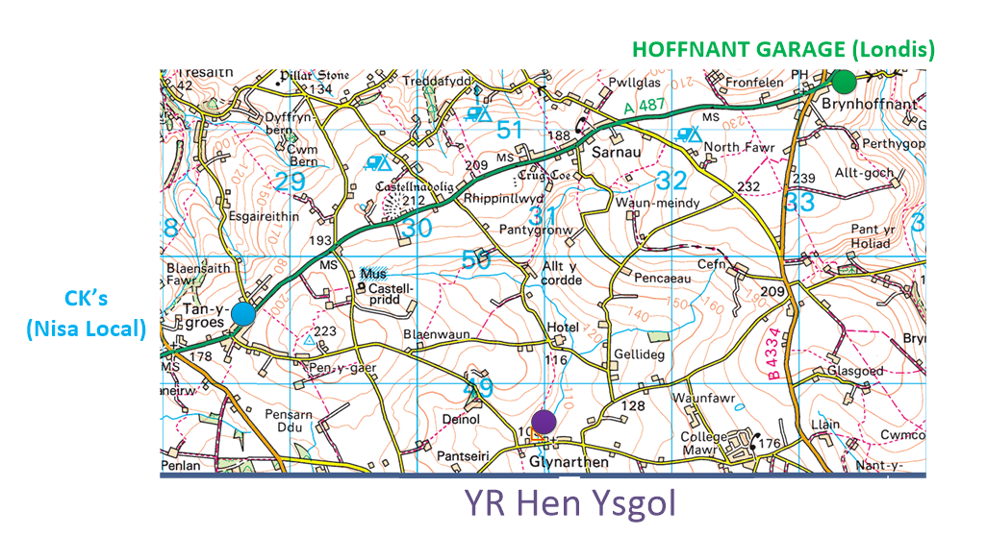

Venue | Opening Hours | Address | Our view
CK’s  (Nisa local)  2.2 miles | Thursday 7.00 - 19.00  Friday 7.00 - 19.00  Saturday 7.00 - 19.00  Sunday 7.00 - 19.00  Monday 7.00 - 19.00  Tuesday 7.00 - 19.00  Wednesday 7.00 - 19.00 | Gogerddan Garage  Tan Y Groes  Cardigan  SA43 2HP | Wider selection of food and cheaper than Brynhoffnant, but lower quality
HOFFNANT GARAGE (Londis)  3.2 miles | Thursday 7 am–8 pm  Friday 7 am–8 pm  Saturday 7 am–8 pm  Sunday 7 am–8 pm  Monday 7 am–8 pm  Tuesday 7 am–8 pm  Wednesday 7 am–8 pm | Brynhoffnant  Nr. Cardigan  Llandysul  Cardigan  Ceredigion  SA44 6ED | Smaller selection than CKs and more expensive, however higher quality and selection of fresh food

Appliances

Oven

The oven is a double oven/grill.
Bottom oven is a fan oven, control on the right hand side of the display
Top oven/grill is not a fan oven, controls are on the left hand side of the display

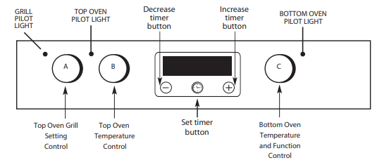
Make and model is Indesit DU6340IX
User guide here https://whirlpool-cdn.thron.com/static/HOU1ZC_400011319037_ND8HCI.pdf?xseo=&response-content-disposition=inline%3Bfilename%3D%22doc.pdf%22

Hob

Hob is ceramic with touch controls
Here is the control panel section, bottom right of the hob:
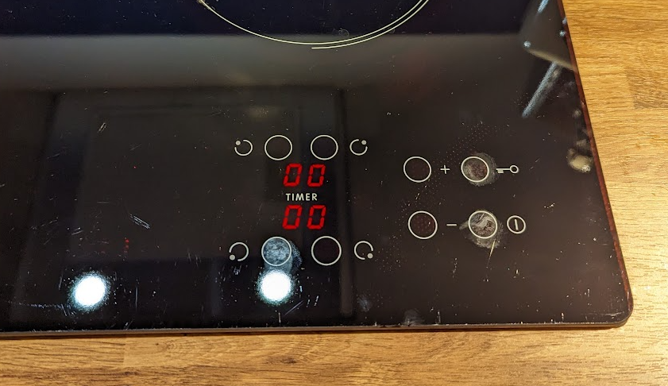

Here are the instructions for the touch buttons:
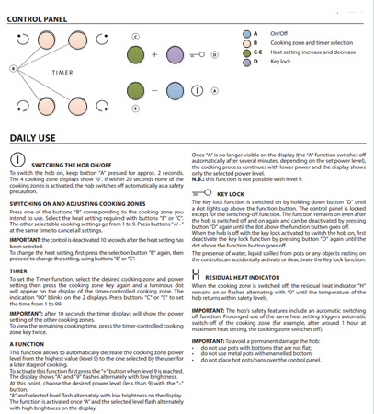

Make and model is Indesit RI161C
User guide here https://whirlpool-cdn.thron.com/delivery/public/document/whirlpool/do-26962bab-f493-4f98-a1be-071b5c8baa2e/jsind9/WEB/doc.pdf

